RealBridge Version 1.2.4
To be released on 1 November 2022 (evening). Please start using this release as soon as possible.

New/changed in this release
- Displaying commentary text on the traveller
- Demonstrating auction and play
- Preparing and playing deals with preset imposed actions
- Exporting a player list: download a simple alphabetical list of all players who have played
- The RealBridge support email address and telephone number are now shown on the login and lobby screens
- Minor changes to PBN results import

Also in this email
- Sample PBN files for use with the new features
- RealBridge top-up training
- Contacting RealBridge

Displaying commentary on the traveller
This feature can be used for:
- Teaching
- Special events (like simultaneous pairs) where commentary has been prepared in advance
- Replaying deals from famous matches where commentary has been provided

Importing commentary
Before the session starts, the Director or Teacher loads a PBN file containing the deals and commentary. This can be done either in Session settings or in Advanced.
The system displays information about what has been loaded.
Two examples: The first one has commentary. The second has results, imposed actions (described later in this email) and PBN commentary.
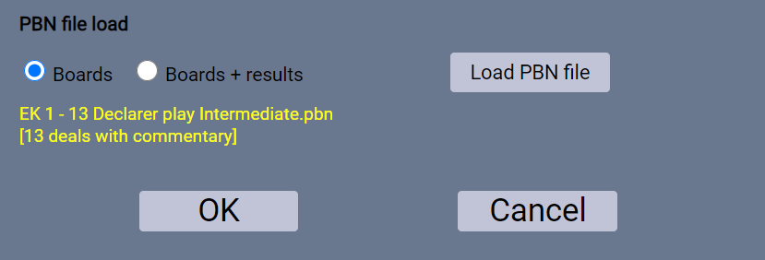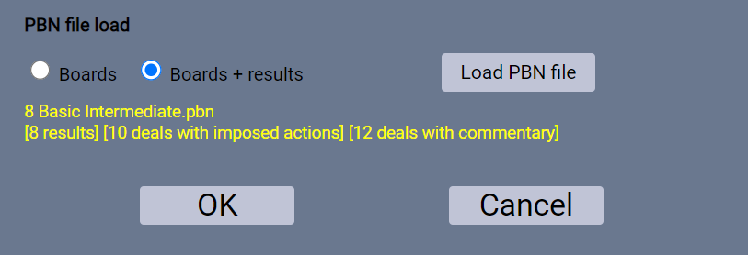

How to display commentary to the players
Advanced button, then tick Show deal commentary

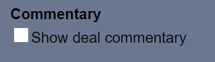
Found here:
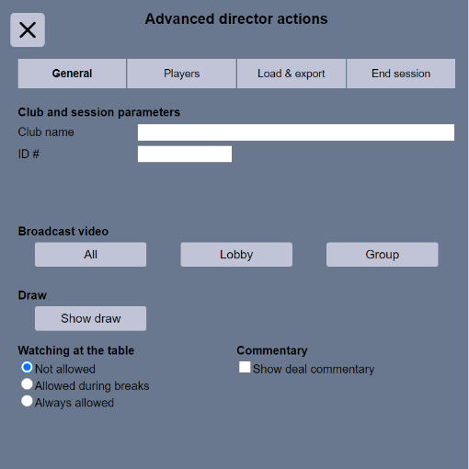
This can be switched on or off again at any time during the session. For example, it could be on all the time, so that the players see the commentary at the end of each hand. Alternatively, you might start with it switched off, then switch it on during a break or at the end of the session.

How the player sees commentary
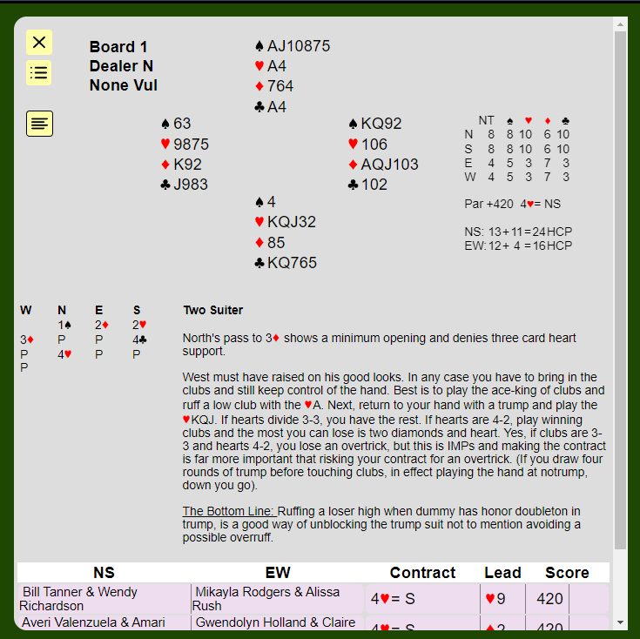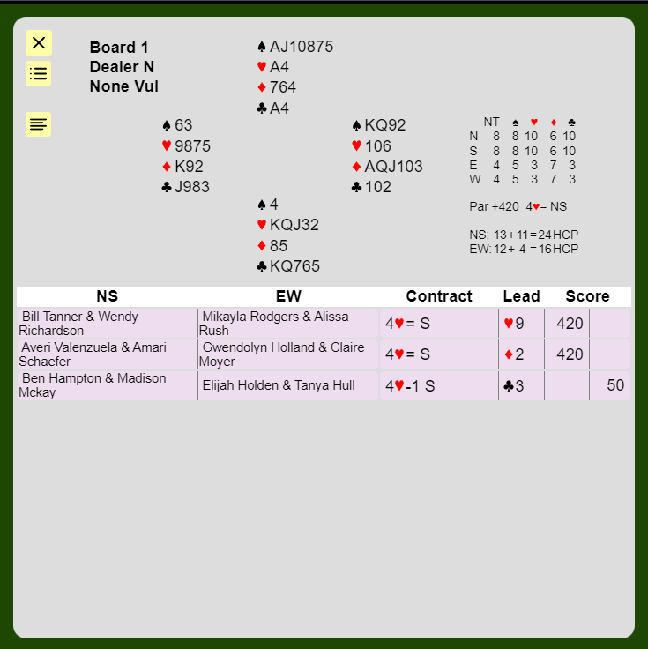

Button to display/hide commentary: clicking this will display the commentary. The results will still appear below the commentary.
Clicking the button again will hide the commentary.
If there is no commentary, no button is displayed on the traveller.

How to create PBN files with commentary
There are 2 approaches:
- Use a PBN editor tool, such as BridgeComposer (there are a few available). The commentary that you enter in your PBN editor will be displayed in RealBridge, with the formatting that you used.
- Edit the PBN using a text editor. This is not recommended for most people, as it is difficult to adhere to the PBN rules/syntax. (For more information, see section 3.8 of the PBN spec. RealBridge ingests and displays all full-line style commentary, that is text that is enclosed in { } characters. End-of-line style commentary is ignored.)
If the deal appears more than once in the file, RealBridge only looks for commentary in the first instance of the deal. So, for example, if the PBN file has 3 results for Board 1, and the teacher wants to add commentary for a lesson, they should add the commentary to the first instance of the board.

Demonstrating Auctions and Play

Loading PBN files
If you are using deals that you have prepared: Load a PBN file with the deals that you want to discuss. (If you also want the players to play these boards, that is fine; if you want the players to play a different set of boards, put the boards to be played first, and the demonstration boards at the end.)
Optional: The PBN may include a “recommended way” to bid or play the board. This can be prepared in a number of ways - see later in this email.
Recommended workflow:
- Session settings
  - Set up the event as you like, either Practice or a Mitchell/Howell
  - Load a PBN file:
    - No results to load? Choose “Boards”
    - Results and “recommended way”? Choose “Boards + results”
- Open the session as usual, and have players sit at tables

Starting a lesson and sharing a deal
- Start a Group broadcast: Advanced -> Group
- Click Share . A screen opens with 2 tabs: Share Content and Share Deal.
    - Sharing content: for Sharing screen, window, slides, etc: Click Share screen
When finished, click Share again, then click Stop screen share . Alternatively, use your web browser’s Stop Sharing button.
    - Sharing deals: click Share Deal. You will see a screen that shows the boards that you loaded from the PBN.
- Select a deal from the dropdown on the left.
- If no results exist, then you can only choose to share the deal with no results. You will provide the auction and play during the demonstration.
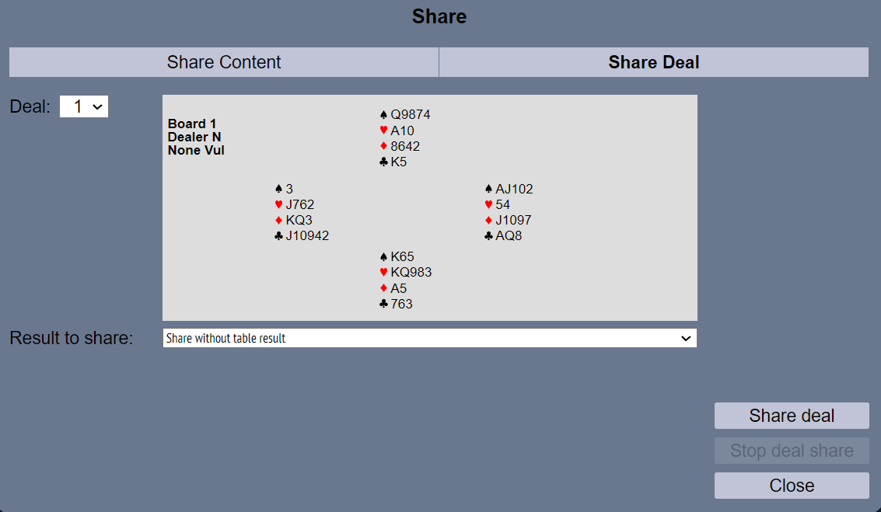
- If results exist: find the result you want to share from the menu, and click Share deal . Your demonstration will be based on the bidding and play from this result.
or
Choose to share the deal with no results. You will provide the auction and play during the demonstration.
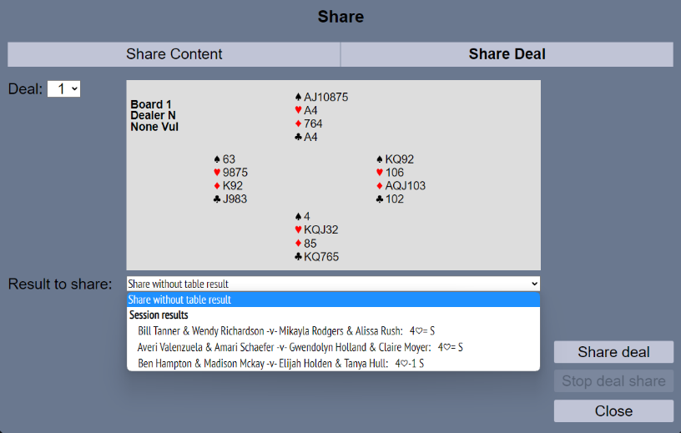
Note: The results on each board are sorted by score and contract.
In all cases, sharing can be ended either by clicking Share again, then Stop deal share ; or by closing the displayed deal using the X at top-left.

Reminder: To end the Group Call itself, click Stop on the yellow band.
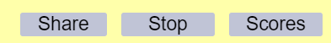

Demonstrating auction and play

Buttons for navigating the auction
These buttons are used:
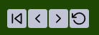
The controls you see allow you to
go back to the start of the auction
step back one step
step forward one step
revert to the complete auction as it happened at the table
Note that sometimes the buttons are greyed out, as they are not relevant at that moment in time.

How to demonstrate auction and play without a table result
Use the bidding box to enter the bids.
Use these buttons to take you back one step, or right back to the start of the auction:
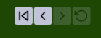
The two buttons on the right are greyed out, because they only apply when you are demonstrating an existing result.

How to demonstrate auction and play for an existing result, varying the auction.

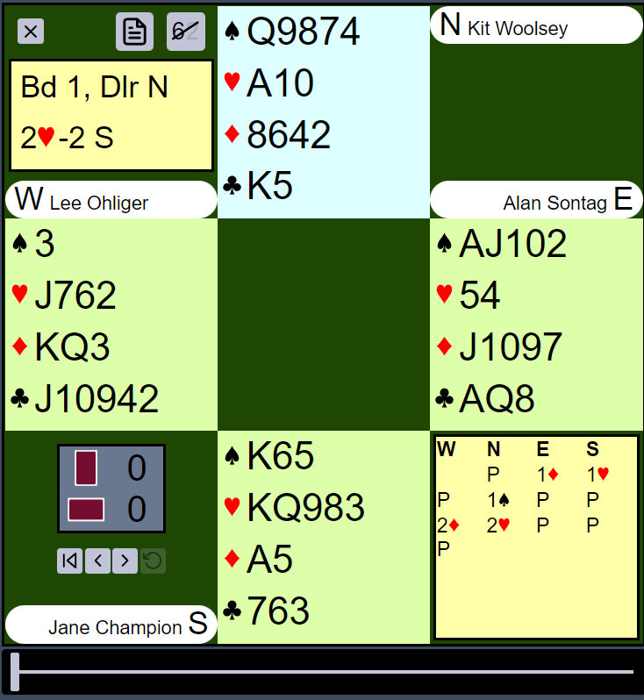
Initially you see the complete auction. To demonstrate the auction or a variation, use these controls:
You can go back to the beginning of the auction, or step back one bid at a time.
When you do this, you can still see the full auction, greyed out. The students (or other people in the Group Call) do not see the greyed-out bids.
To step through the original auction, use the step-forward button (or you can use the bidding box if you prefer).
To change the auction, use the bidding box to enter the bids.
If the auction you are demonstrating is consistent with the original auction, the greyed-out bids remain visible. When you deviate from the original auction, the greyed-out bids disappear. They will reappear when you step backwards into the original auction.

Example
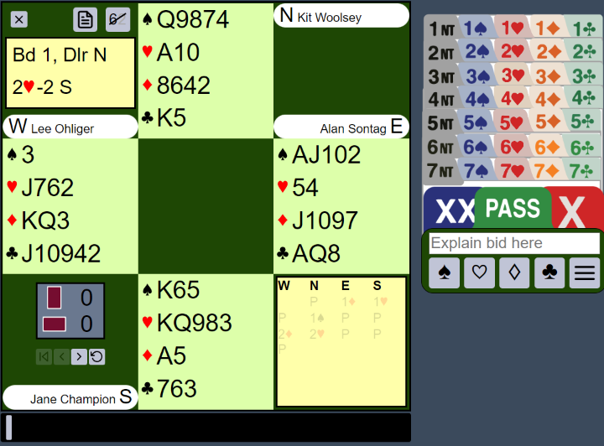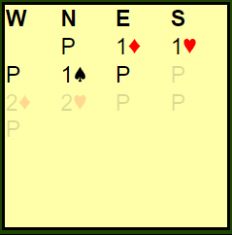
The original auction ended with North playing in 2 Hearts. You have stepped back to East’s second-round pass.
Now, if you bid 2 Spades with the South hand, changing the auction, the bid table changes to:
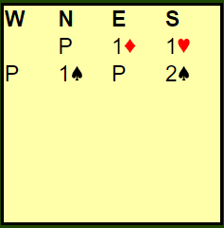

How to demonstrate auction and play for an existing result, varying the play
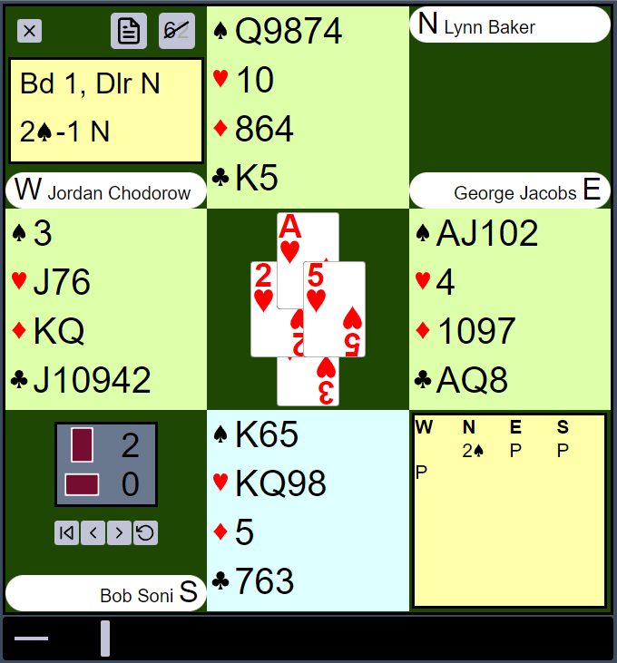
In the example above, a board is broadcast. The teacher has varied the line of play from trick 2 onwards.
Notice now there is a gap between the horizontal line and the vertical bar.
Demonstrating play was released in RealBridge 1.2.1. In RealBridge 1.2.3, this works the same way, but note that you can now change the auction, then demonstrate how to play a different contract.

Imposed actions

Summary
This feature allows you to predetermine part or all of the bidding, and optionally the opening lead. For example:
(a) North must open 3 Diamonds, and East must pass. Now South decides what to bid, and the auction continues from there.
(b) The declaring side must have bid 2NT-3NT, and the player on lead must lead the ten of hearts. Then the play continues as normal.
This feature can be used for:
- Teaching and coaching
- Par contests, or similar events where the contract or the beginning of the auction is predetermined.

How does it work?
When preparing a PBN file, a special code is included to indicate that the board has “imposed” actions.
When you set up the session, you specify that the imposed actions are to be used.
When the board arrives at the table, the players see exactly what they would see as if they had made the bids themselves.

Contents of the PBN file
In the PBN record, include part or all of the auction, and if required part of the play. You can include more actions than what you want to impose. For example, you can include the entire budding and play, but only impose the first three bids of the auction.
Within the PBN record, include a line like this:
- % RBIMPOSE B -- Impose all the bids that are in the PBN record. (You can also use % RBIMPOSE A , for “auction”.)
- % RBIMPOSE L -- Impose the entire auction and the opening lead
- % RBIMPOSE 7 -- Impose exactly 7 actions.
If you impose a specific number of actions, these actions can be either bids or plays. For example, if there are 6 bids in the auction (including the final three passes):
- % RBIMPOSE 3 means that RealBridge will impose the first three bids (including passes).
- % RBIMPOSE 6 means that RealBridge will impose the entire auction. (In this example that is equivalent to % RBIMPOSE B.)
- % RBIMPOSE 7 means that RealBridge will impose the entire auction and the opening lead. (In this example that is equivalent to % RBIMPOSE L.)
- % RBIMPOSE 10 means that RealBridge will impose the entire auction and the first trick.
The number can be as high as 90. You can go as far into the play as you like (but the team at RealBridge don’t think anyone is likely to go beyond trick 1).

Data restrictions
PBN files must have good data! Note that:
- If the opening lead has been imposed, a complete auction is needed, and at least the first card of the play.
- If a number of actions has been imposed, the PBN record must contain at least that many actions.
- The code must be formatted exactly as above – % at the start of the line, 1 space after the %, 1 space after RBIMPOSE. Otherwise it will not be detected as an instruction. (You can have extra spaces at the end of the line.)
- There should only be one % RBIMPOSE line per deal. If you included more than one % RBIMPOSE line, only the first will be used.
- If the % RBIMPOSE line does not have a valid code, it will be ignored, with a warning message.
- You do not need to impose actions on every deal. For example, perhaps deals 1 to 4 have imposed actions, but deals 5 and 6 do not.
- If the deal appears more than once in the file, RealBridge only looks for % RBIMPOSE codes in the first instance of the deal. So, for example, if the PBN file has 3 results for Board 1, and the teacher wants to adapt it for a lesson, they should edit the first instance of the board.

Adding the % RBIMPOSE codes to the PBN
The codes can be added to a PBN file using any text-editor. If you need help with this, please contact support@realbridge.online
Your PBN editing program may let you enter the codes directly.
BridgeComposer will soon have built-in support for the % RBIMPOSE functionality, so that you will be able to specify the imposed actions via a dialog box.

Loading the PBN file
Load the PBN file as normal. The number of imposed actions will be shown on screen:
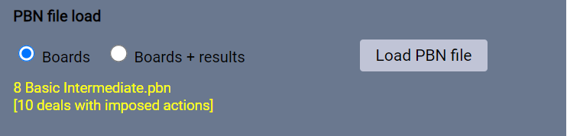

Enabling imposed actions
Before the session starts, in Session settings, Options, tick this option:

Warnings and errors
When you load the PBN file
- If the "% RBIMPOSE" line has an invalid code (or no code), a warning message is displayed.
When the Start Round 1 button is clicked
- If Impose actions is ticked, but there are no imposable actions in the PBN, an error message is displayed.
- If Impose actions is not ticked, but there are imposable actions for the boards to be played, a warning is displayed

What the players see
When the board arrives at the table:
- The imposed bids have already been made.
- If any card-plays are imposed, the cards are imposed, players make the imposed plays themselves, but they can only play the imposed card. The imposed card is popped out ready to play.
A player can request an undo as normal. A director can impose an undo. If there is an undo back into the imposed actions, bidding and play are then unrestricted.

Imposed actions with imported results or commentary
If you also specify to import results, and the PBN record includes a contract + declarer + score, it also gets included as an imported result. It is included in scoring, and is available for the teacher to demonstrate.
You can also add commentary to the deal.
Hence one PBN record can be used for all of:
- Imposed actions, using % RBIMPOSE
- Commentary, using the PBN commentary syntax
- As a result for including in comparisons
- For demonstration of the auction and/or play.

New Config keys
These new config keys have been added:
- impose_actions - boolean
- show_commentary - boolean

Exporting a player list
When you click the USEBIO button, a new report is created. This contains all the players that have played more than 1 board. The player name, whatever they entered in ID number, and the number of boards they have played. The list is in alphabetical order. When you open the file in a spreadsheet (eg Excel), it will look like the screenshot below.
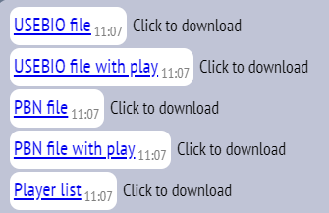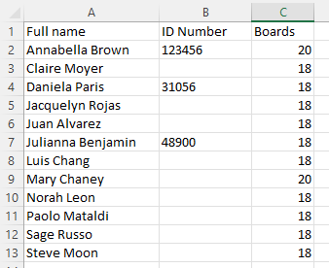

Login and lobby screens
The RealBridge support email address and telephone number are now shown on the login and lobby screens.
If you have a problem when running a session, please contact us. If one of your players has a technical problem with RealBridge, please encourage them to contact us.

Changes to PBN results import
If you import results from a PBN file, but a PBN record has blank names, RealBridge now accepts the result. It uses generated player-names like “N01”, “E02”, “S01, “W01”.
If you have already loaded a PBN file with results, and you later go back into Session settings, the radio button will already be set to Boards + results.
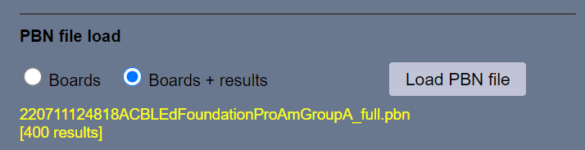

Sample PBN files
To get people going with these new features, we have prepared 2 sets of PBN files. These are available here:
https://realbridge.online/teacher-resources
Eddie Kantar 13 deals: these are for Intermediate+ players. The themes are this type of thing: good technique, careful entry management, and timing for drawing trumps, ducking.
Beginner-intermediate 16 deals: these are basic hands. The players are expected to know Stayman. There are no overcalls to be made, nor will you see pre-emptive bidding. Hands 1 to 8 are copied to 9 to 16, but a few cards are changed, and a different seat gets to be dealer.
The files contain commentary, imposed actions, and complete recommended auction and play. You can choose which features to use.
Note that with either of these files, if you choose to:
- Run as a duplicate, you are advised to choose a “2 winner Mitchell”, so that each seat gets their fair share at declaring.
- Run as a session with more boards in the file, then that works, just specify as many boards as you like; the rest will be random.

Only want to play some of the boards?
Then just play, for example, 1 to 8. Next time, load the file, and in Session settings set the starting board number to, for example, 9.

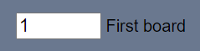

We intend to add more files in November and December. These will have commentary, and imposed actions.

RealBridge top-up training
These courses are intended for club managers, directors and teachers, who are already used to running duplicates and teaching sessions on RealBridge. They are not intended for players.
Each course is about 10 to 15 minutes. You don’t have to book – just join the link below at the specified time.

Who should attend?
- Directors
- Teachers & Coaches

Course content
Broadcasting, demonstrating auction and play - especially relevant for teachers and coaches
- Before start
- During game
Using PBN files to impose actions on the game (eg bidding, lead) – ideal for teachers and coaches, and directors who want to run par contest games
- How to make the data
- How to configure RealBridge
- What players must do (and relevance of “Undo”)
Using PBN files to display narrative on the traveller – ideal for teachers and coaches, and directors who want to run events with prepared commentary (eg simultaneous pairs)
- How to make the data
- How to configure RealBridge (When to show the commentary: at the start, or at the end? Or anytime you want.)
- How everyone sees it

Dates and times (all in English), but live subtitles are also available in other languages.
Date | Day | Language | UK (UTC) | Central Europe | New York  (Eastern) | Australia  Sydney | New Zealand
1 Nov | Tue | English + subtitles in German | 9am | 10:00 |  | 8pm | 10pm
1 Nov | Tue | English + subtitles in French | 3pm | 16:00 | 11am
1 Nov | Tue | English | 11pm | Midnight | 7pm
2 Nov | Wed | English |  |  |  | 10am | Noon
2 Nov | Wed | English + subtitles in German | 8am | 09:00 |  | 7pm | 9pm
2 Nov | Wed | English + subtitles in French | 3pm | 16:00 | 11am
2 Nov | Wed | English + subtitles in Italian | 6pm | 19:00 | 2pm
3 Nov | Thu | English + subtitles in Italian |  |  |  |  | 7am
3 Nov | Thu | English + subtitles in German | 9am | 10:00 |  | 8pm | 10pm
3 Nov | Thu | English + subtitles in Danish | 2pm | 15:00 | 10am
3 Nov | Thu | English + subtitles in Norwegian | 6pm | 19:00 | 2pm
4 Nov | Fri | English + subtitles in Norwegian |  |  |  |  | 7am
6 Nov | Sun | English + subtitles in German | 11am | Noon |  | 10pm | Midnight
7 Nov | Mon | English + subtitles in Swedish | 9am | 10:00 |  | 8pm | 10pm
7 Nov | Mon | English + subtitles in Italian | 4pm | 17:00 | 11am
9 Nov | Wed | English + subtitles in French | 9am | 10:00 |  | 8pm | 10pm

Joining instructions
Please click
www.tinyurl.com/realbridge
It is helpful if you arrive a few minutes early.

Contacting RealBridge
If you have a problem during a session, please call us on one of the numbers below. We are happy to take your call, and we want people to contact us for help. Normal hours are 7am to 11pm UK, but for emergencies you can call outside these times.
For less urgent questions, please email us.
Our email address is: support@realbridge.online
Numbers for contacting RealBridge (including immediate support issues):
+44 (0) 794 232 2209
+44 (0) 772 692 0784

Our email address is: support@realbridge.online . If you do not wish to get these emails, please reply to this email, asking us to remove you.

